Mr SGs Kinetic Molecular Theory Notes

Kinetic Molecular Theory

-The kinetic molecular theory (KMT) is a theory developed to explain the properties of gases

-Under the kinetic theory, a number of assumptions are made. As such it is said to apply to “ideal gases”

-gases consist of tiny particles that move rapidly in random straight lines until they contact each other or the wall of their container`

-collisions between particles/walls are perfectly elastic

-as the size of particles is so small compared to the sized of the container, particles are treated as if they have mass but no volume

-attractive/repulsive forces between gas particles are assumed to be negligible

-average kinetic energy of particles and hence velocity increases with temperature

-Kinetic theory explains many physical properties of gases (compressibility, low density, diffusion, pressure etc)

-Diffusion: particles continue moving in straight lines until they contact the wall of their container

-Compressibility: As volume of gas particles is negligible compared to the volume of their container they occupy, most of the gas sample is empty space

-Pressure: The force of the gas particles colliding with the walls of their container. This is dependent on the momentum of the particles (dependant on their velocity) and the frequency of the collisions (dependant on the number of particles in a given area).

Gas Laws
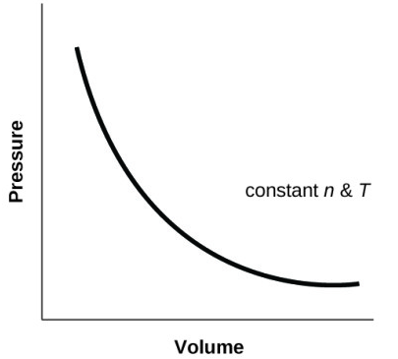

Boyle’s Law

-Boyle’s law uses KMT to explain the relationship between the volume a gas occupies and the pressure it exerts on its container

-Pressure is the force exerted by gas particles colliding with the walls of their container over a given area

-If you reduce the volume of a gas sample, the space between the gas particles will be reduced and collisions with the walls of the container will become more frequent

-Volume is inversely proportional to Pressure

-For a fixed mass of gas at constant temp, PV is constant, so:

P₁V₁=P₂V₂ (P=kPa/ mmHg/ atm, V=L)

Charles’ Law
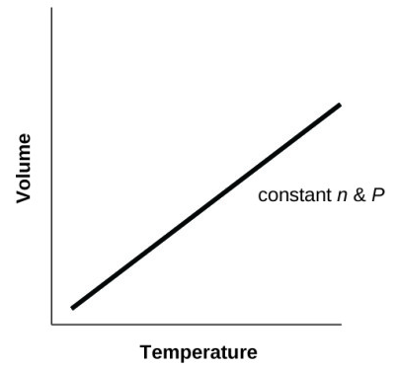

-Charles’ Law uses KMT to explain the relationship between the temperature of a gas and the volume it occupies

-Temperature is a measure of the average kinetic energy of particles

-If the particles of a gas are at a higher temperature, and moving faster, this will either result in more collisions with the container walls (if volume is fixed), or a greater volume (if the pressure does not change)

-T is proportion to V, T is proportional to P

-Charles' Law: V₁ = V₂ (T= degrees Kelvin)
T₁ T₂

-Note: temperature is always expressed in Kelvin (K = °C + 273.15) as it is the kinetic energy of the particles that affects volume and pressure. As 0°C does not correspond to a complete absence of kinetic energy, only K is proportional to the amount of kinetic energy of the particles

Gay-Lussac’s Law
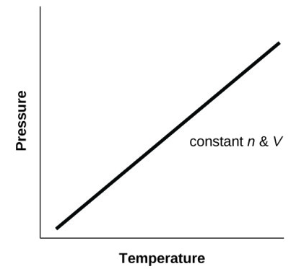

-Gay-Lussac’s Law describes the relationship between temperature and pressure

-It states that for a given mass and constant volume of an ideal gas, pressure is proportional to absolute (e.g. in Kelvin) temperature

P₁= P₂
T₁ T₂

Combined Gas Law

-These laws can be combined to give the combined gas law (PV/T is constant)

P₁V₁ = P₂V₂
T₁ T₂

-This law can be used to predict the effect of changing the pressure, volume or temperature of a gas

STP

-STP (standard temperature and pressure) refers to a series of standard conditions that chemical reactions are often carried out under or referred to under

STP= 273.15 K 100.0 kPa

-Note that the definition of standard pressure recently changed from 101.3 kPa to 100 kPa, so some textbooks still refer to the older definition

Practice Calculations

- 2.00 L of CO₂ at STP is heated to 20°C in a container of fixed volume. Assuming the volume does not change, what is the gases new pressure?

- 4.54 L of N₂ at STP is compressed, increasing the pressure to 251 kPa. The temperature of the gas increases to 5°C. What volume does the gas now occupy?

Molar Volume & the Ideal Gas Law

-As well as temperature and pressure, the volume of a gas depends on the number of gas particles present

-Avogadro hypothesised that “equal volumes of gases at the same temperature and pressure contain equal numbers of particles”

-This relates to the assumption of KMT that the volume occupied by gas particles is negligible compared with the volume occupied the gas

-V is proportional to n

-As such, 1 mole of any gas should occupy the same volume at a constant pressure and temperature

-1 mole of any gas should occupy the same volume at STP (the molar volume)

-This volume is 22.71 L

n = V_{STP}
22.71

Practice Calculations

- Calculate the volume occupied by 2.37 mol of hydrogen gas at STP

- Calculate the number of moles of carbon dioxide gas in a volume of 16.3 L at STP

- Calculate the volume occupied by 14.5 g of sulfur dioxide gas at STP

Stoichiometry involving gases (at STP)

-The molar volume can be used to calculate the number of moles of gaseous reagents involved in chemical reactions, or to calculate the volume of gas produced in a reaction.

Practice Calculations

- Calculate the mass of water produced when 17.5 L of ethane at STP completely combusts in excess oxygen.

- Calculate the volume of carbon dioxide produced at STP, when 1.23 g of calcium carbonate reacts with excess hydrochloric acid.
-As the volume of any gas is proportional to the number of moles present, the reaction coefficients can be used to calculate the volumes of gas produced for reactions that involve only gaseous reactants and products

e.g. 2H_{2(g)} + O_{2(g)} → 2H₂O_{(g)}

means 2 moles of hydrogen will react with 1 mole of oxygen to produce 2 moles of water AND 2 L of hydrogen will react with 1 L of oxygen to produce 2 L of water

Practice Calculations

- Calculate the volume of water produced (at STP) when 4.0L of propane combusts in excess oxygen.

Calculations involving gases at non-standard conditions

-It is possible to use molar volume law in conjunction with the combined gas law to calculate the volume occupied by a given number of moles of gas under any conditions

-First calculate the volume at STP, then use the combined gas law to convert the volume to non-standard conditions

-It can also be used to calculate the number of moles contained in a volume of gas under non-standard conditions

-First use the combined gas law to convert the volume to volume at STP, then use the molar volume calculation to calculate the number of moles

-In practice, this method is not used as the Ideal Gas Law allows us to complete the calculation more efficiently

Practice Calculations

- What volume does 4.67 moles of nitrogen gas occupy at a temperature of 25.4 ᴼC and a pressure of 98.4 kPa?

- How many moles of oxygen gas are contained in a volume of 67500 0 L at a temperature of 18 ᴼC and a pressure of 112 kPa?

Ideal Gas Law (not in Yr 11 syllabus)

-The combined gas law tells us that ((PV)/T) is constant for a given number of gas particles (e.g. a given number of moles of a gas)

-n is proportional to (PV)/T

-The ideal gas law adds the Universal Gas Constant R (8.314 J K⁻¹ mol⁻¹) to the equation to make the quantities directly relatable to each other

PV = nRT

-By rearranging this equation, we can calculate the number of moles of a given volume of gas at non-standard conditions

-This allows us to go from n to V or vice versa under non-standard conditions in one less step than would be required using the combined gas law and the molar volume calculation

m₁ m₂
(solids/liquids) (solids/liquids)
n= m m = nM
M V = n V₂
c (solutions)
c₁ & V₁ n = cV
(solutions) n₁ n₂ c = n
n = V_{STP} V c₂
22.71 n₂ = coefficient₂ x n₁ (solutions)
coefficient₁ V_{STP} = n x 22.71
V₁(STP)
(gases) n = PV V₂(STP)
RT (gases)
V = nRT
V₁ P
(gases) V₂
(gases)

Practice Calculations

- What volume does 0.914 moles of methane gas occupy at a temperature of 18.0 ᴼC and a pressure of 101.4 kPa?

- Calculate the volume of hydrogen gas produced (at 25.0 ᴼC and a pressure of 97.3 kPa when 24.5 g of magnesium reacts with excess hydrochloric acid.

Changes of State

-Kinetic theory can be used to explain the behaviour of solids and liquids and changes of state

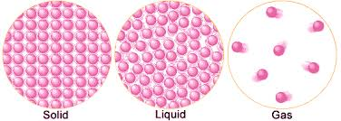
Solid Liquids Gases
-Tightly packed particles -Tightly packed particles -Particles far apart
-Vibrate around fixed position -Move past one another -Move rapidly
-Lowest E_{K} -Moderate E_{K} -Highest E_{K}

-Changes in state occur when the E_{K} of the particles increases, allowing them to overcome the forces holding the particles in their solid or liquid configurations

Energy and changes of state

-All particles possess kinetic energy (E_{K}) due to their motion and potential energy (E_{P}) due to their position

- In solids where the particles are close together, the particles have low E_{P}

-In gases where the particles are far apart, they have high E_{P}

-When substances change state, they gain E_{P} due to the energy added to overcome the IM forces that hold the particles together

-Temperature: average kinetic energy of particles in a substance

-Heat (thermal energy): energy transferred between objects that are different temperatures

-This can be observed in heating and cooling curves, where the time heated or cooled (e.g. the amount of kinetic energy) is plotted on the x-axis and the temperature of a substance is plotted on the y-axis
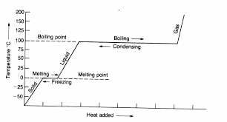
Heating
Cooling
-As gas cools, E_{K} is lost to the surroundings
-As gas condenses, E_{P} is lost to surroundings, as particles take up the liquid configuration
-As liquid is cools, as E_{K} is lost to surroundings
-As liquid freezes, E_{P} is lost to surroundings, as particles take up the solid configuration
-As solid cools, E_{K} is lost to the surroundings

-As solid is heated, energy is added as E_{K}
-As solid melts, energy is added as E_{P} to overcome forces holding particles in solid lattice
-As liquid is heated, energy is added as E_{K}
-As liquid boils, energy is added as E_{P} to overcome forces holding particles in proximity
-As gas is heated, energy is added as E_{K}

Evaporation

-Evaporation is a change of state from liquid to gas that occurs below the boiling point of the liquid

-Particles in a substance have a range of E_{K}, some much higher than the average

-If a particle near the surface has sufficient E_{K}, it can overcome the attractive forces of its neighbours, leave the liquid and become a gas

-Evaporation lowers the temperature (average E_{K}) of the liquid, as only the particles with the highest E_{K} leave the liquid due to evaporation
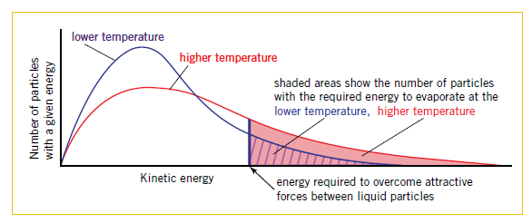
-Evaporation increases with increasing temperature, as a higher proportion of particles have enough E_{K} to evaporate
Vapour Pressure

-When a liquid is placed in a sealed container, the volume of the liquid will initially decrease due to evaporation before stabilising
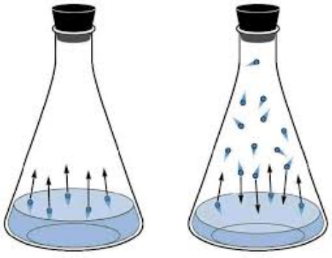
-Both evaporation and condensation are occurring inside the container

-Evaporation occurs at a constant rate for a constant temperature

-Initially, the condensation is zero, but this increases with the increasing number of gas particles

-When the liquid volume stabilises, rates of evaporation and condensation are equal (system in a state of dynamic equilibrium)

-The gas particles in the container exert a pressure due to their collisions with the walls

-This is called the vapour pressure of a liquid

-Vapour pressure varies between substances, depending on the strength of the IM forces present and the temperature

-Substances with high vapour pressure are called volatile substances

Boiling

-While evaporation only occurs at the surface of a liquid, boiling occurs when particles throughout a substance change state from liquid to gaseous, as bubbles of gas form throughout the liquid

-These bubbles form at any temperature, however below a substances boiling point the bubbles collapse before becoming large enough to see due to the force of atmospheric pressure pushing down on the surface of the liquid

-The more a substance is heated the more it’s vapour pressure increases, increasing the pressure inside the bubbles of gas that form

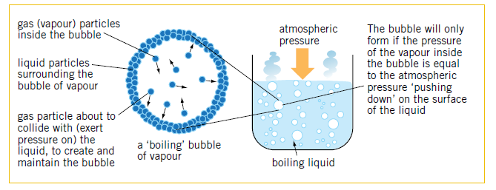

-The boiling point of a substance is the point at which its vapour pressure is equal to atmospheric pressure

-At the boiling point, the bubbles have enough pressure inside them to resist the force of atmospheric pressure, so they can continue to grow and rise to the top of the liquid, releasing the gas inside.

-This means that boiling point varies with varying atmospheric pressure (e.g. water boils at around 70°C at the top of Mt Everest where atmospheric pressure is lower

-Increasing atmospheric pressure increases BP (e.g. in a pressure cooker, water boils at around 120°C, due to the increased pressure above the surface of the liquid)

Colligative Properties

-When a solute is added to a liquid, it interferes with these processes of evaporation and boiling

-The presence of a dissolved solute results in reduced evaporation at the surface of the liquid

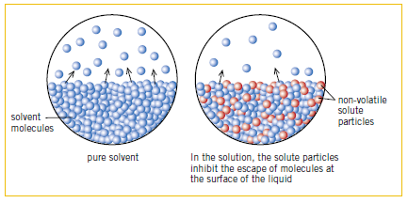
-This reduces the vapour pressure and increases boiling point, as the temperature at which vapour pressure = atmospheric pressure is increased

-The more solute is present, the greater the extent to which vapour pressure is reduced and boiling point is elevated

-Properties of a solution of that vary with the concentration (but not the identity) of dissolved solutes are known as colligative properties

-The three colligative properties that we study are vapour pressure, melting point and boiling point

-Melting point is lowered as presence of solute particles interferes with crystallisation

